Question 1

The protocols that appear are “Internet protocol v4 (IPv4)”, “Transmission control protocol (TCP)” and “Hypertext transfer protocol (HTTP)”.

Question 2

It took 0.129 seconds from HTTP GET was sent, until HTTP OK was received.

Question 3

The internet address of gaia.cs.umass.edu is 128.119.245.12 and mine is 192.168.1.186

Question 4

Packet list window:



Packet-header for HTTP GET:

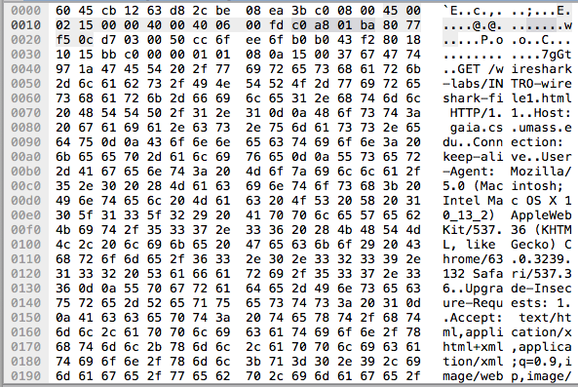

Packet-header for HTTP OK:

